**Fuzzy Controller for Quarter Car Active Suspension System**

# **Introduction**

Many studies are carried out to increase the driver comfort of cars. One of these comfort-providing efforts is the suspension systems of cars. Passive suspension systems without control systems were trying to reduce the vibrations coming from the wheels or the oscillations occurring on bumps by dampening them. After that, active control systems were developed by adding a controller. Active control systems cannot yet meet the level of car safety and comfort demanding from customers. Many techniques developed for the controller used in active suspension systems are available in the literature. Fuzzy logic is one of them. Thanks to Fuzzy Logic's success in evaluating gray areas not only black and white (1-0), vibrations can be dampened more accurately and fast. The actuator controlled by the controller is placed in the car between the car body and the wheels. It ensures that the car body keeps still in the vertical axis or minimizes its movement by decreasing or increasing the distance between the car body and the wheel in the up and down movements of the wheels.

Since active suspension systems are complex and nonlinear systems, model-based control methods are inadequate. Therefore, fuzzy set-based control systems are more suitable and used. Many methods have been used in the literature for the active controller. These are PID (Proportional-Integral-Derivative) [X2], MPC (Model Predictive Control) [X1], LQG (Linear Quadratic Gaussian) [X3], H-infinity [X4], SMC (Sliding Mode Control) [X5] and Fuzzy [X6]. (Burdaki makale konularında biraz detay bilgilerin verilmesi.)

Studies in the literature have also carried out membership functions as triangular and trapezoidal. The value ranges were mostly determined equally. In this study, unlike the literature, Gaussian membership functions were used instead of triangular or trapezoidal in fuzzy control membership functions, and the value ranges were adjusted to provide optimum control. In this way, as shown in this paper, more comfort and safety is provided than the produced by other membership functions. With the use of proposed membership function, a 46.24% decrease in car body displacement compared to the closest membership function has occurred. This value is very interesting in terms of reducing the actuator dimensions, reducing the costs and minimizing the energy used as well as providing driving comfort and safety.

# **Mathematical Model of Suspension System**

A quarter car suspension system consists of one-fourth of car, sprung and damper total mass value. The system measuring vertical acceleration of car body and wheel has 2-DOF model. In active control system, there is control input to dampen the shock vibrations. There are many methods for active control systems. The main purpose of suspension control is to keep the car vertical acceleration at zero or minimize it.

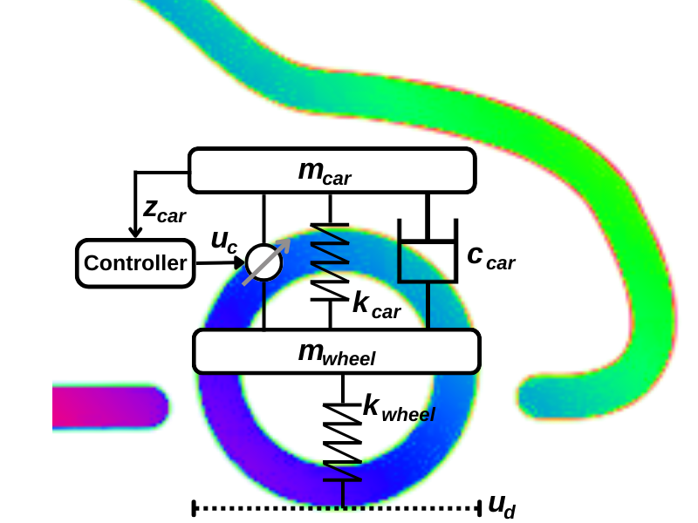

Figure 1: Active control system for quarter car model.

Figure 1 shows the plant model for car suspension model. In this model, there are car sprung, damper and control input unit, which are between car body and wheel, and wheel sprung which is between wheel and road. The control input unit control the distance between car body and wheel.

Table 1: Parameter values used in proposed model.

|  |  |
| --- | --- |
| Parameter | Value |
| Sprung Mass ($m_{car}$) | 320 kg |
| Unsprung Mass ($m_{wheel}$) | 40 kg |
| Actuator Force ($u_{c}$) | 10,000 N |
| Stiffness of Damper ($k_{car}$) | 18,000 N/m |
| Stiffness of Tyre ($k_{wheel}$) | 200,000 N/m |
| Damping Coefficient of Damper ($c_{car}$) | 1000 N/m/s |

When the Newton’s second law is applied to the plant model showing in figure 1, the equations showing below can obtain.

$$\begin{aligned}{\overset{¨}{z}}_{car}=\frac{c_{car}\left({\overset{˙}{z}}_{wheel}-{\overset{˙}{z}}_{car}\right)+k_{car}\left(z_{wheel}-z_{car}\right)+uc}{m_{car}} \#\left( SEQ Equation \backslash * ARABIC 1\right)\end{aligned}$$

All z symbols call vertical movement value. ${\overset{¨}{z}}_{car}$ is acceleration on the car body at z axis. The main purpose is making ${\overset{¨}{z}}_{car}$ zero or minimize it. It depends on damper force, sprung force, and control input force. ${\overset{˙}{z}}_{car}$ is velocity of car body. ${\overset{˙}{z}}_{wheel}$ is velocity of wheel. $z_{car}$ is car body vertical position. $z_{wheel}$ is wheel vertical position.

$$\begin{aligned}{\overset{¨}{z}}_{wheel}=\frac{-c_{car}\left({\overset{˙}{z}}_{wheel}-{\overset{˙}{z}}_{car}\right)-k_{car}\left(z_{wheel}-z_{car}\right)+k_{wheel}\left(ud-z_{wheel}\right)-uc}{m_{wheel}} \#\left( SEQ Equation \backslash * ARABIC 2\right)\end{aligned}$$

${\overset{¨}{z}}_{wheel}$ is acceleration on the wheel. It depends on damper and sprung force between car body and wheel, sprung force between wheel and road and control input force. The state space equation of the model showing in figure 1 is above. Hence this model has two inputs (control input and road disturbance), the state space equation is better.

$$\begin{aligned}\left[\begin{matrix}{\overset{˙}{z}}_{car} \\ {\overset{¨}{z}}_{car} \\ {\overset{˙}{z}}_{wheel} \\ {\overset{¨}{z}}_{wheel}\end{matrix}\right]=\left[\begin{matrix}0 & 1 & 0 & 0 \\ \frac{-k_{car}}{m_{car}} & \frac{-c_{car}}{m_{car}} & \frac{k_{car}}{m_{car}} & \frac{c_{car}}{m_{car}} \\ 0 & 0 & 0 & 1 \\ \frac{k_{car}}{m_{wheel}} & \frac{c_{car}}{m_{wheel}} & \frac{-\left(k_{car}+k_{wheel}\right)}{m_{wheel}} & \frac{-c_{car}}{m_{wheel}}\end{matrix}\right]*\left[\begin{matrix}z_{car} \\ {\overset{˙}{z}}_{car} \\ z_{wheel} \\ {\overset{˙}{z}}_{wheel}\end{matrix}\right]+\left[\begin{matrix}0 & 0 \\ \frac{1}{m_{car}} & 0 \\ 0 & 0 \\ \frac{-1}{m_{wheel}} & \frac{k_{wheel}}{m_{wheel}}\end{matrix}\right]*\left[\begin{matrix}uc \\ ud\end{matrix}\right] \#\left( SEQ Equation \backslash * ARABIC 3\right)\end{aligned}$$

The state variables given in equations (3) illustrate the vertical movement of car body and the wheel. $k_{wheel}$ indicates the stiffness of sprung which is between wheel and road. $k_{car}$ indicates the stiffness of sprung which is between car body and wheel. $c_{car}$ indicates the damping coefficient of damper. $uc$ indicates control force where is between car body and wheel. $ud$ states the road disturbance input.

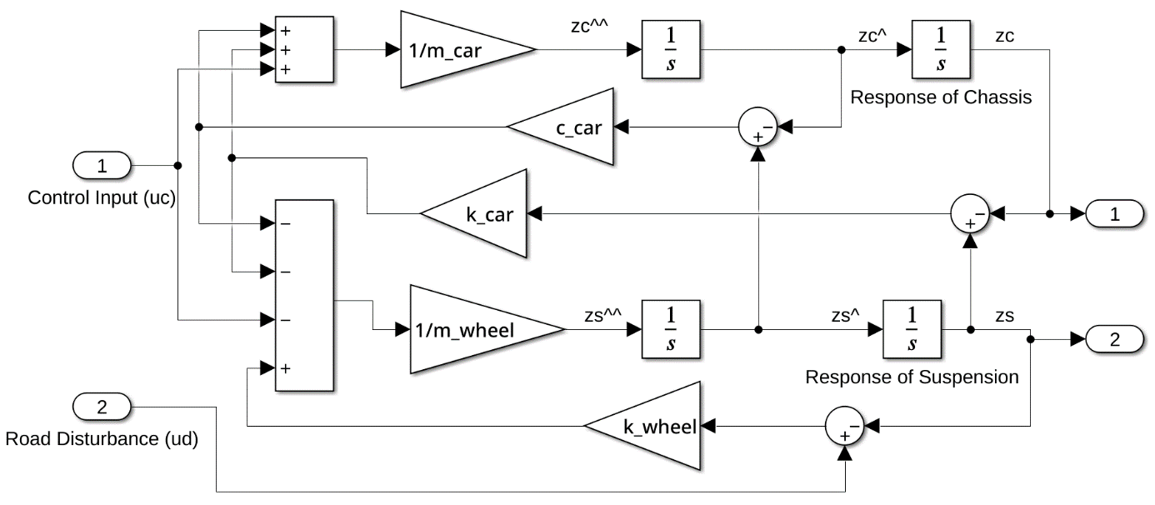

Figure 2: Mathematical model belonging to quarter car suspension system.

Figure 2 shows mathematical model of quarter car active suspension model in MATLAB Simulink software program. This program simplifies designing physical plant. Designed model provides to watch all variables on it. The model has two inputs and two outputs. It gets the control and road disturbance values. Car body and wheel position at z-axis are computed according to the model.

# **Fuzzy Controller Design**

The fuzzy logic controller has two inputs that are car body displacement $z_{car}$ called as error ($e$) and velocity ${\overset{˙}{z}}_{car}$ called as change in error ($c_{e}$). It has one output that is desired actuator force uc. The Fuzzy Logic Controller has three steps that fuzzification, fuzzy inference system (FIS) and defuzzification. The real values are converted into fuzzy values in fuzzification step. FIS processes the fuzzy values and calculate output by using rules and data. In this study, Mamdani approach was used for interpretation in rule base. The computed output consists of fuzzy values. The output values convert into real values in defuzzification step. There are many techniques for this conversion. The most commonly used technique is centroid technique.

$\begin{aligned}Z_{COG}= \frac{\int_{Z}^{ }{μ_{A}(Z)Zdz}}{\int_{Z}^{ }{μ_{A}(Z)dz}} \#\left(4\right)\end{aligned}$

Equation (4) indicates the formulation of centroid technique. $μ_{A}(z)$ is the aggregated membership function, z is the output variable coming from FIS and $Z_{COG}$ is output variable computing from defuzzification step.

Membership functions are very important for rule base control systems. Determining of optimum interval for each membership function is provide significant accurate control. It is related to which plant is studied on. For the suspension systems, decreasing the zero parts is increasing the success rate. Triangular and trapezoidal functions of the members are mostly employed in literature. Nevertheless, Gaussian function is more suitable for active suspension systems as indicated in this paper. Hence, Gaussian membership function was employed in this study.

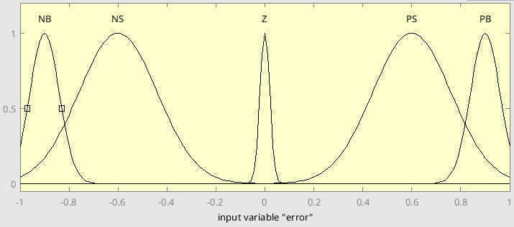

Figure 3: Membership function for “Error” input.

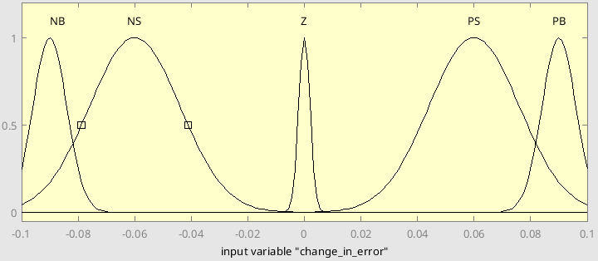

Figure 4: Membership function for “Change In Error” input.

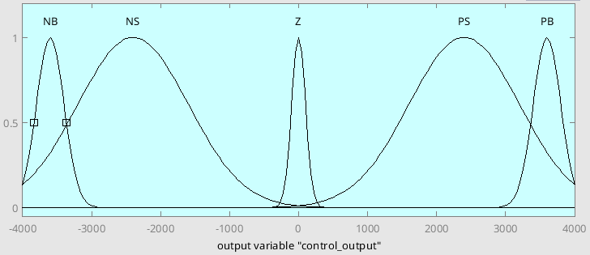

Figure 5: Membership function for “Actuator Force” output.

Figure 3 and 4 state for input membership functions and figure 5 states for output membership function of the fuzzy logic control (FLC). The membership functions for each variable were divided into five categories. The abbreviations used in this study are; NB is Negative Big, NS is Negative Small, Z is Zero, PS is Positive Small and PB is Positive Big. The Big’s and Zero membership functions were attempted to small range, but the Small’s are wide range.

Table 2: Fuzzy logic rules table.

|  |  |  |  |  |  |
| --- | --- | --- | --- | --- | --- |
| e \ cE | NB | NS | Z | PS | PB |
| NB | NB | NB | NS | NS | Z |
| NS | NB | NS | NS | Z | PS |
| Z | NS | NS | Z | PS | PS |
| PS | NS | Z | PS | PS | PB |
| PB | Z | PS | PS | PB | PB |

Table 2 indicates the rule base of the FLC. Hence there are five members for each input, there are 25 control rules in the rule base. This table states “If Then” construct, the “If” part is the conditions (for this, there are two conditions – e, cE) and “Then” part is the result (output - uc). The case in rule base for this FLC model is such a R: If (e = NS) AND (cE = Z) Then (uc = NS).

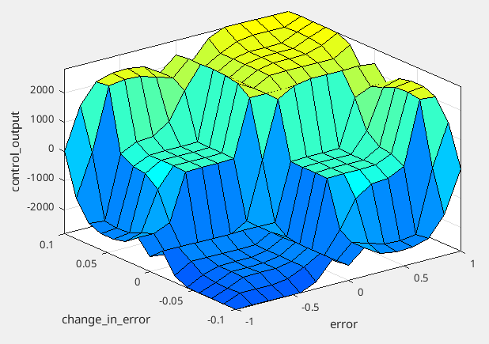

Figure 6: Fuzzy logic rules surface plot.

Figure 6 indicates the fuzzy logic rules surface plot for the input and output variables. It shows 3 dimension graph, which indicates the correlation among inputs and output.

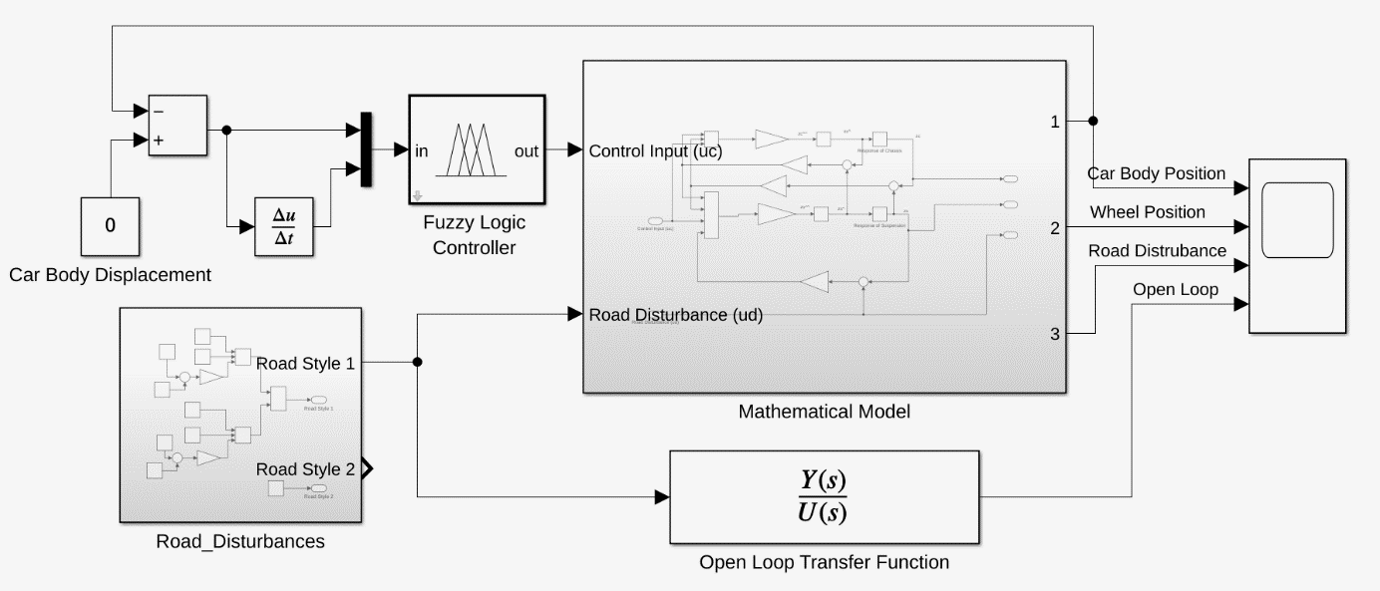

Figure 7: The block diagram of fuzzy logic control.

Figure 7 indicates the MATLAB Simulink model for quarter car active suspension control system in MATLAB Simulink. The model consists of desired car body displacement value, FLC model, the mathematical model of quarter car suspension, road disturbance profiles and transfer function of the mathematical model mentioned above. The desired displacement value is objective value of minimizing the vertical movement. Road disturbance block includes two different road profiles used in this paper. Transfer function was used for comparing with uncontrolled and controlled system.

# **Simulation Results**

The proposed study mentioned in this article was to investigate how different membership functions result in the damping of quarter car active suspension systems. The performance of the proposed models was carried out by comparing with the two different road profiles showing figure 8 and 9 created using bumps and potholes.

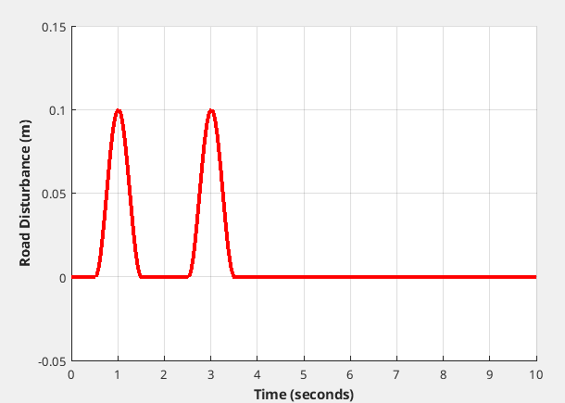

Figure 8: The first road profile for simulation

First road profile has two bumps with 2 seconds delay and 10 centimeters height. There are two bumps to examine the sequential bump effect on the car suspension system.

$$\begin{aligned}u_{d}=\left\{\begin{aligned}0.05(1-\cos\left(2πt+\frac{3}{2π}\right), &1.5≥x>0.5 \\ 0.05(1-\cos\left(2πt+\frac{3}{2π}\right), &3.5≥x>2.5 \\ 0, & otherwise\end{aligned}\right.\#\left(5\right)\end{aligned}$$

The equation (5) indicates mathematical values of the first road disturbance having 0.1 m amplitude.

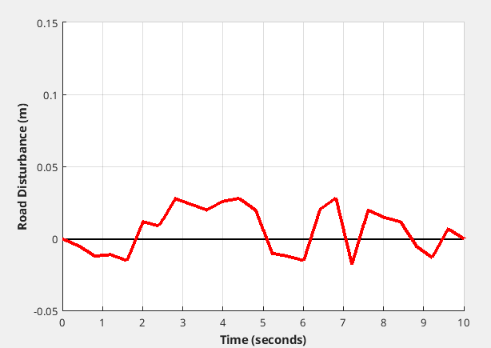

Figure 9: The second road profile for simulation.

Second road profile has poly line whose varies between -2 and 3 centimeters height. It used for examining the effect of continuous road disturbance on car suspension system. Table 3 shows the points of the used poly line.

Table 3: The points of the second road disturbance line.

|  |  |  |  |  |  |
| --- | --- | --- | --- | --- | --- |
| Time (second) | Height (m) | Time (second) | Height (m) | Time (second) | Height (m) |
| 0 | 0.0 | 3.6 | 0.020 | 7.2 | -0.018 |
| 0.4 | -0.005 | 4.0 | 0.026 | 7.6 | 0.020 |
| 0.8 | -0.012 | 4.4 | 0.028 | 8.0 | 0.015 |
| 1.2 | -0.011 | 4.8 | 0.020 | 8.4 | 0.012 |
| 1.6 | -0.015 | 5.2 | -0.010 | 8.8 | -0.005 |
| 2.0 | 0.012 | 5.6 | -0.012 | 9.2 | -0.013 |
| 2.4 | 0.009 | 6.0 | -0.015 | 9.6 | 0.007 |
| 2.8 | 0.028 | 6.4 | 0.020 | 10.0 | 0.0 |
| 3.2 | 0.024 | 6.8 | 0.028 |  |  |

The MATLAB Simulink software program was used to compute better membership functions. There are four different membership functions used in this article. “Triangular Gaussian” membership functions (mf) consists of triangular mf where has same range with proposed “Gaussian” mf. “Trapezoidal” mf consists of trapezoidal mf with equal interval. The difference between “Triangular Equal” and “Triangular Gaussian” is that the “Triangular Equal” mf has equal intervals. “Gaussian” mf is better membership functions compared to the membership functions used in literature. It consists of different range membership functions with different wide.

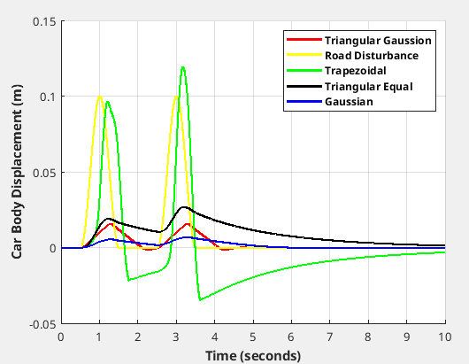

Figure 10: Car body displacement for first road profile.

There is no any permanent offset in car body displacement in the "Gaussian" and "Triangular Gaussian". But "Gaussian" mf has less overshoot value compared to other membership functions.

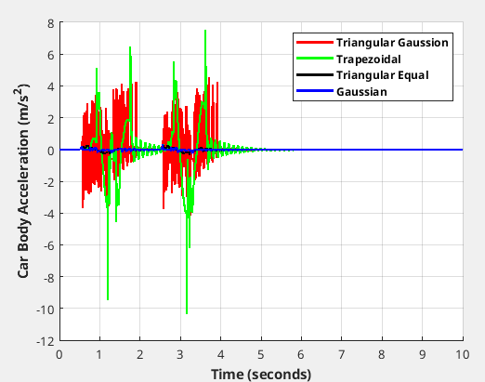

Figure 11: Car body acceleration for first road profile.

Figures 10 and 11 shows for first road profile car body displacement and acceleration responded under four membership functions. When the figure 10 investigated, yellow line states road disturbance line. Blue line states the proposed membership function output. The graph infers that proposed mf provides the best driving comfort and safety compared to other membership function. For acceleration shown in figure 10, “Trapezoidal” most commonly used membership function in literature is close to “Gaussian” mf proposed in this article. But “Trapezoidal” mf has more harmonics than proposed mf.

Table 4: Compare the membership function at achieve rate for road profile 1.

|  |  |  |  |
| --- | --- | --- | --- |
| Membership Function | Success Criteria ($mm$) | | |
| RMS | Max | Mean |
| Triangular Gaussian | 5.241 | 15.93 | 2.465 |
| Trapezoidal | 30.65 | 119.2 | -1.068 |
| Triangular Equal | 11.83 | 26.88 | 9.454 |
| Gaussian | 2.818 | 7.214 | 1.802 |

Table 4 shows the different criteria values for four membership function. Root Mean Square (RMS) is the significant success criteria to evaluate the achieve rate of active suspension system. Maximum (Max) is used for obtain overshoot value. Mean is another method to evaluate achieve rate. "Trapezoidal" and "Triangular Equal" is commonly used technique in literature. But, RMS value of this techniques have dramatically difference comparing to the proposed technique in this study. "Triangular Equal" is about four higher than "Gaussian" which is proposed in this article under RMS and Max success criteria.

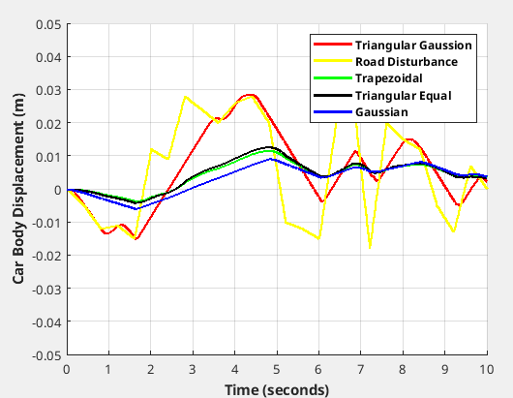

Figure 12: Car body displacement for second road profile.

The proposed membership function has less overshoot and  settling time comparing to other membership functions, which presents the efficiency of the proposed membership function.

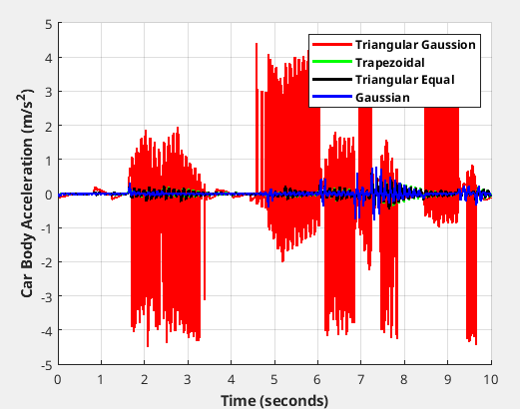

Figure 13: Car body acceleration for second road profile.

Figure 12 and 13 show the response of four different mf used in this study under second road disturbance. The proposed Gaussian mf has the most damper for road disturbance vibrations comparing to other membership function mostly used in literature. Figure 12 shows the changing car body acceleration at vertical axis position.

Table 5: Compare the membership function achieve rate for road profile 2.

|  |  |  |  |
| --- | --- | --- | --- |
| Membership Function | Success Criteria ($mm$) | | |
| RMS | Max | Mean |
| Triangular Gaussian | 12.76 | 28.40 | 5.576 |
| Trapezoidal | 5.921 | 11.65 | 4.233 |
| Triangular Equal | 6.335 | 12.73 | 4.448 |
| Gaussian | 5.293 | 9.107 | 3.068 |

The proposed technique under RMS success criteria showing in table 5 has the best stable condition under continuous road disturbance.

# **Conclusion**

Quarter car active suspension systems are nonlinear dynamic system which is hard to use analytical control techniques. Nonetheless, fuzzy logic controller technique, intelligent control method, can control in high accuracy. In fuzzy logic controller, choosing membership function affects the accuracy. This study has proposed the highest accuracy membership function which is Gaussian. When the proposed mf is compared with the common used mf’s which are trapezoidal and triangular, it is the best suitable choice for implementation of quarter car active suspension systems. The simulation results indicate that proposed membership function reduces car body displacement by 46.24% over the technique which is the closest to proposed technique for bumps. For potholes road disturbance, proposed mf reduces by 10.60% over the closest membership function for potholes. These results demonstrate that the driving comfort and safety is achieved massively by using the proposed membership function. In the future studies, it can compare the effect of defuzzification functions such as centroid and bisector.

# **References**

[X1] Bououden, S. & Chadli, M. & Karimi, Hamid. (2015). A Robust Predictive Control Design for Nonlinear Active Suspension Systems. Asian Journal of Control. 18. 10.1002/asjc.1180.

[X2] Sharkawy, Abdel-Nasser & Ali, Ahmed & Ghazaly, Nouby & Abdel-Jaber, Gamal. (2015). PID CONTROLLER OF ACTIVE SUSPENSION SYSTEM FOR A QUARTER CAR MODEL. International Journal of Advances in Engineering & Technology. Vol. 8. 899-909.

[X3] Elmadany, Mohamed & Abduljabbar, Zuhair & Professor, Associate. (1999). Linear Quadratic Gaussian Control of a Quarter-Car Suspension. Vehicle System Dynamics - VEH SYST DYN. 32. 10.1076/vesd.32.6.479.4224.

[X4] Fallah, Saber & Bhat, Rama & Xie, Wen-Fang. (2009). H(infinity) Robust Control of Active Suspensions: A Practical Point of View. Proceedings of the American Control Conference. 1385 - 1390. 10.1109/ACC.2009.5160098.

[X5] Deshpande, Vaijayanti & Bhaskara, Mohan & Phadke, Shrivijay. (2012). Disturbance observer based sliding mode control of active suspension systems. Journal of Sound and Vibration. 333. 70-75. 10.1109/VSS.2012.6163480.

[X6] Palanisamy, Senthilkumar & Karuppan, Sivakumar. (2016). Fuzzy control of active suspension system. Journal of Vibroengineering. 18. 3197-3204. 10.21595/jve.2016.16699.